Experiment 1.3

Create an application to calculate interest for FDs, RDs based on certain conditions using inheritance.

**Student Name: Parikshit sharma UID: 19BCS4520**

**Branch: CSE-IOT-1 Section/Group: A**

**Semester: 4 Date of Performance: 22-2-2021**

**Subject Name: PROJECT BASED LEARNING IN JAVA Subject Code: CSP296P**

**1. Aim/Overview of the practical:** Create an application to calculate interest for FDs, RDs based on certain conditions using inheritance.

To calculate the interest based on the age ,type of account and display the output as the amount based on the age and money .

2. Task to be done: To calculate the interest based on the age ,type of account and display the output as the amount based on the age and money .

**3. Apparatus: Java Compiler**

**4. Algorithm/Flowchart :**

**a. create an account class.**

**b. Then create FD,RD and SD classes.**

**c. Take the input of amount.**

**d. Create launcher class.**

**5. Theme/Interests definition:**

**INHERITANCE :** Inheritance is one of the important feature of the object oriented programming. Inheritance is the process of acquiring the properties ,behaviour ,mechanism from a parent class.

**For example:**



**Types of inheritance :**

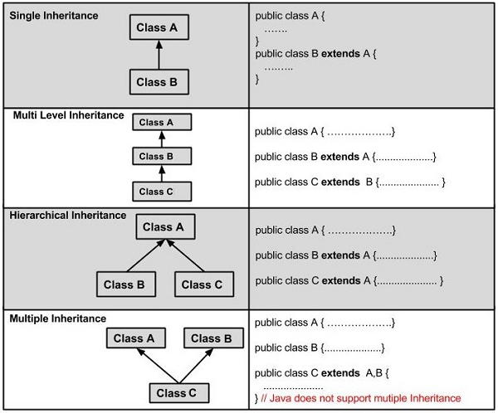

**6. Steps for experiment/practical:**

* **Firstly open any java compiler and create a new project java application and name it .**
* **Now after creating the project create the classes separately based on our application. In this we are using Account class, Interest calculator, FD, RD, etc.**
* **Secondly ,Create the inheritance class and connect the classes to main class using the concept of inheritance and make sure that you create an exception so that you can access them without any error or exception caused while executing the project.**
* **Finally, Now run the project if there are no errors and enter the choice from the menu bar, enter the type of account, age ,enter the amount based on these details the system will calculate automatically and display the interest to be paid.**

**7. Observations/Discussions(For applied/experimental sciences/materials based labs):**

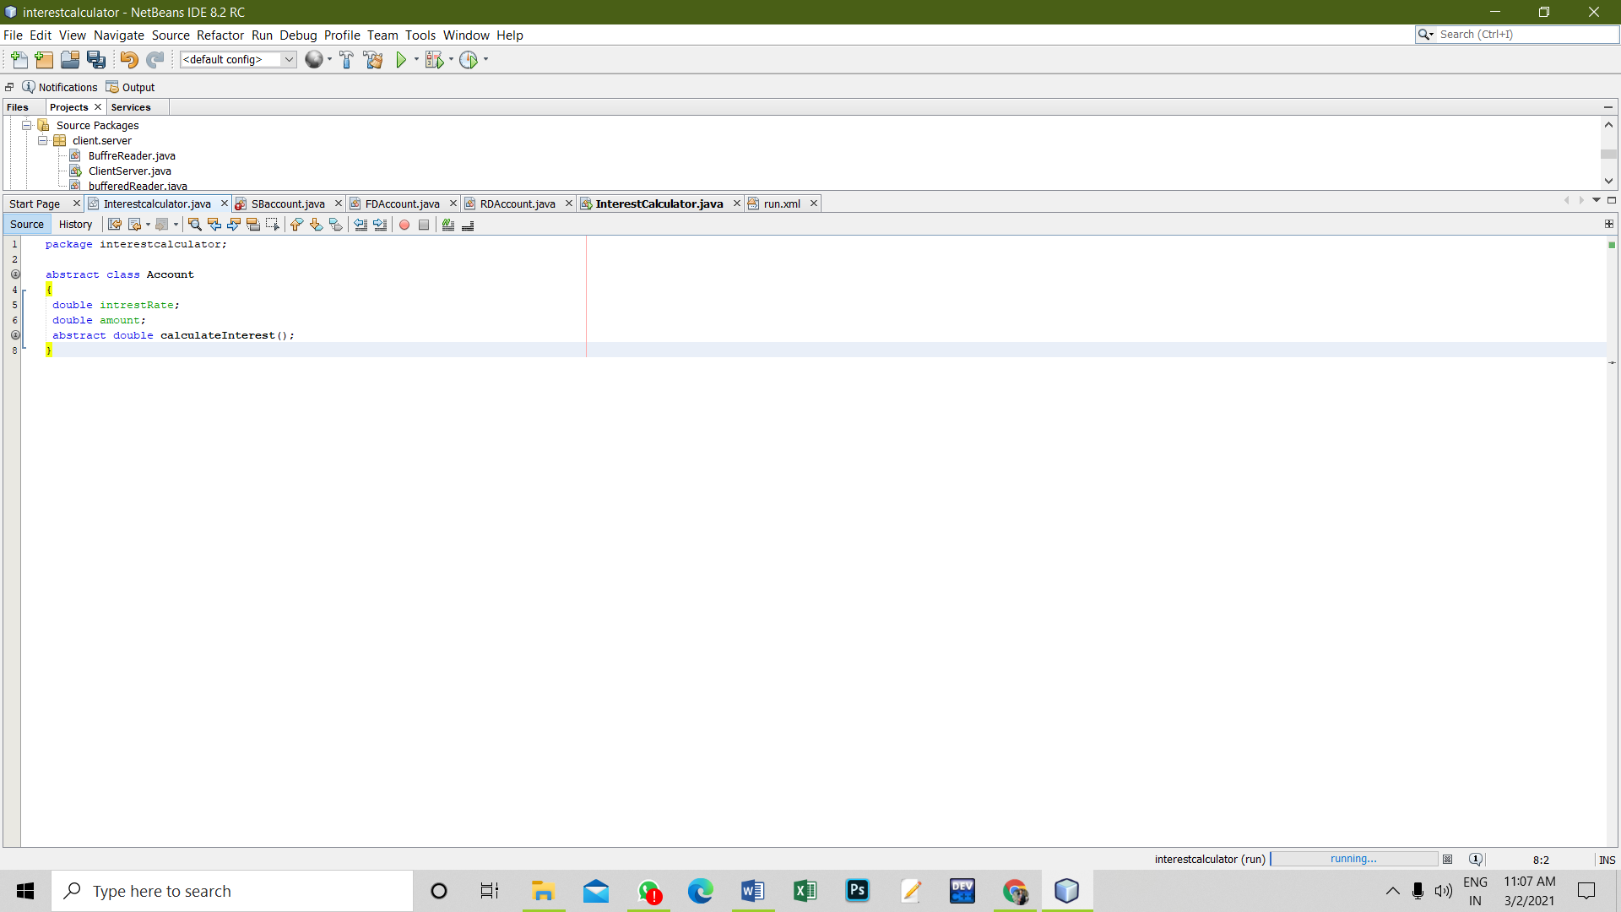

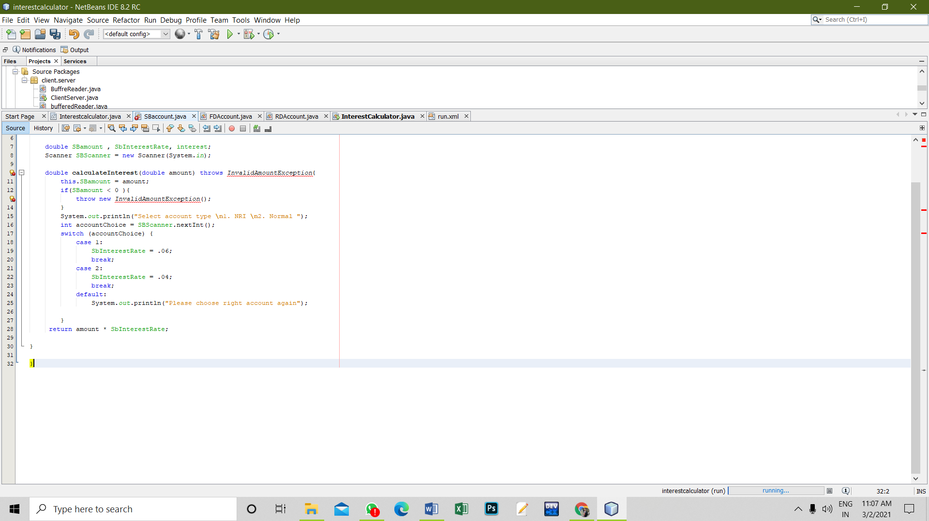

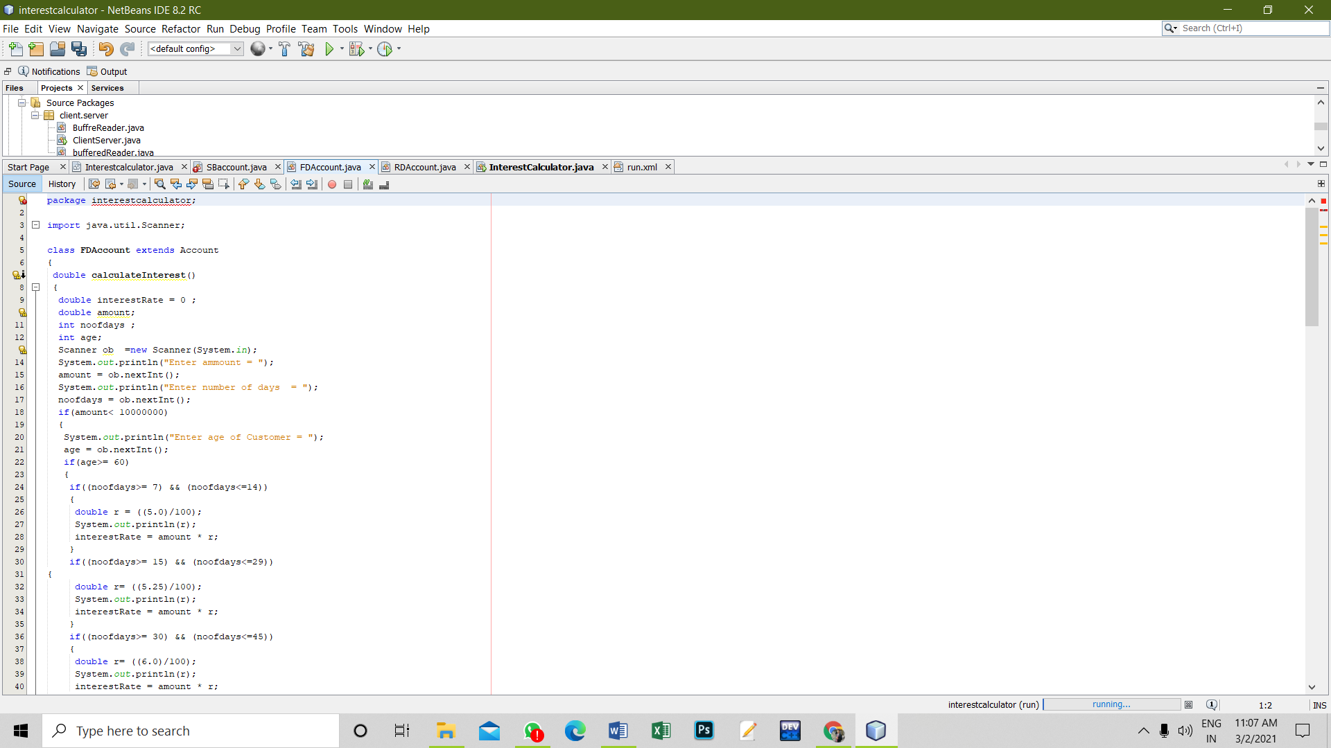

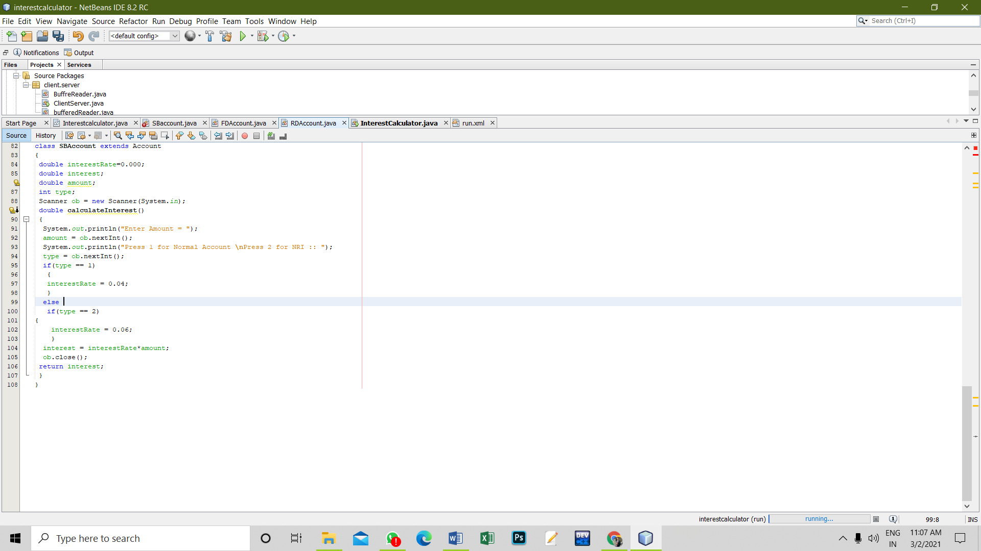

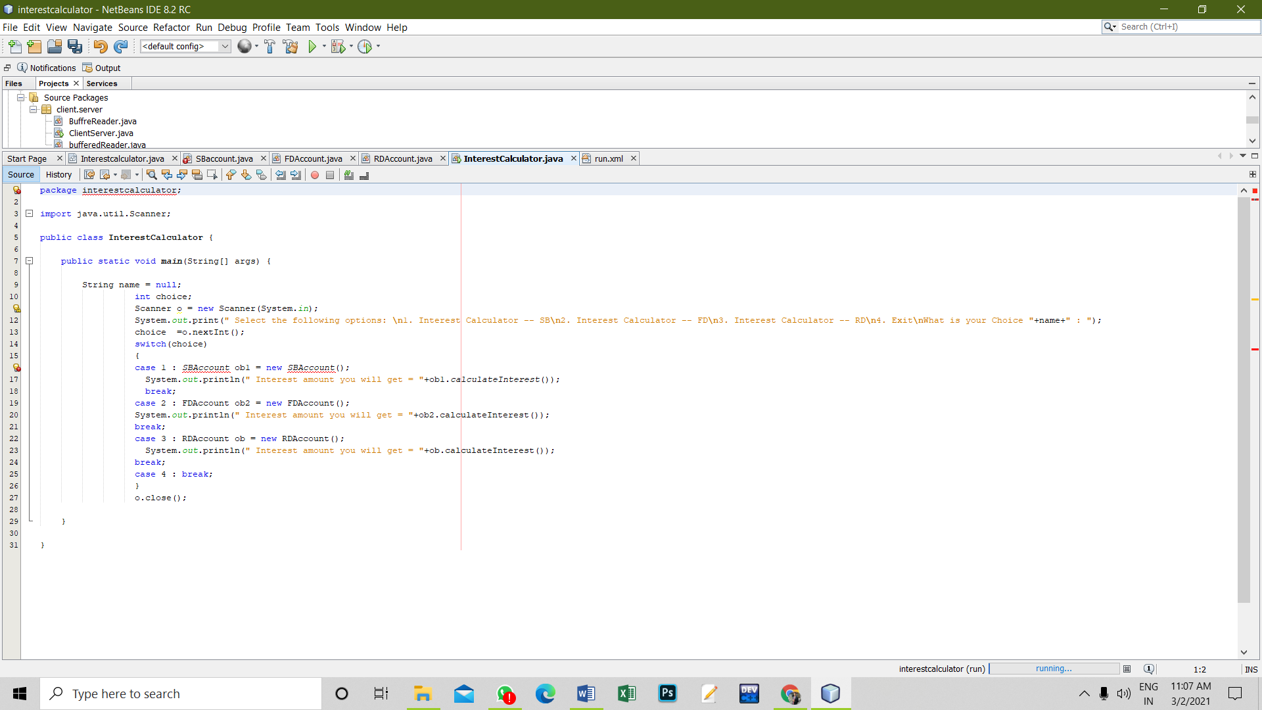

**8. Percentage error (if any or applicable):no**

**9. Calculations/ Chemical Reactions / Theorems /Formulas used etc :**

**ACCOUNT CLASS**

**package interestcalculator;**

**abstract class Account**

**{**

**double intrestRate;**

**double amount;**

**abstract double calculateInterest();**

**}**

**FD ACCOUNT CLASS**

**package interestcalculator;**

**import java.util.Scanner;**

**class FDAccount extends Account**

**{**

**double calculateInterest()**

**{**

**double interestRate = 0 ;**

**double amount;**

**int noofdays ;**

**int age;**

**Scanner ob =new Scanner(System.in);**

**System.out.println("Enter ammount = ");**

**amount = ob.nextInt();**

**System.out.println("Enter number of days = ");**

**noofdays = ob.nextInt();**

**if(amount< 10000000)**

**{**

**System.out.println("Enter age of Customer = ");**

**age = ob.nextInt();**

**if(age>= 60)**

**{**

**if((noofdays>= 7) && (noofdays<=14))**

**{**

**double r = ((5.0)/100);**

**System.out.println(r);**

**interestRate = amount * r;**

**}**

**if((noofdays>= 15) && (noofdays<=29))**

**{**

**double r= ((5.25)/100);**

**System.out.println(r);**

**interestRate = amount * r;**

**}**

**if((noofdays>= 30) && (noofdays<=45))**

**{**

**double r= ((6.0)/100);**

**System.out.println(r);**

**interestRate = amount * r;**

**}**

**if((noofdays> 45) && (noofdays<=60))**

**{**

**double r= ((7.5)/100);**

**System.out.println(r);**

**interestRate = amount * r;**

**}**

**if((noofdays>= 61) && (noofdays<=184))**

**{**

**double r= ((8.0)/100);**

**System.out.println(r);**

**interestRate = amount * r;**

**}**

**if((noofdays>= 185) && (noofdays<=365))**

**{**

**double r= ((8.50)/100);**

**System.out.println(r);**

**interestRate = amount * r;**

**}**

**}**

**else**

**if(age< 60)**

**{**

**if((noofdays>= 7) && (noofdays<=14))**

**{**

**double r= ((4.5)/100);**

**System.out.println(r);**

**interestRate = amount * r;**

**}**

**if((noofdays>= 15) && (noofdays<=29))**

**{**

**double r= ((4.75)/100);**

**System.out.println(r);**

**interestRate = amount * r;**

**}**

**if((noofdays>= 30) && (noofdays<=45))**

**{**

**double r= ((5.50)/100);**

**System.out.println(r);**

**interestRate = amount * r;**

**}**

**if((noofdays> 45) && (noofdays<=60))**

**{**

**double r= ((7.0)/100);**

**System.out.println(r);**

**interestRate = amount * r;**

**}**

**if((noofdays>= 61) && (noofdays<=184))**

**{**

**double r= ((7.5)/100);**

**System.out.println(r);**

**interestRate = amount * r;**

**}**

**if((noofdays>= 185) && (noofdays<=365))**

**{**

**double r= ((8.0)/100);**

**System.out.println(r);**

**interestRate = amount * r;**

**}**

**}**

**}**

**else**

**if(amount>=10000000)**

**{**

**if((noofdays>= 7) && (noofdays<=14))**

**{**

**double r= ((6.50)/100);**

**System.out.println(r);**

**interestRate = amount * r;**

**}**

**if((noofdays>= 15) && (noofdays<=29))**

**{**

**double r= ((6.75)/100);**

**System.out.println(r);**

**interestRate = amount * r;**

**}**

**if((noofdays>= 30) && (noofdays<=45))**

**{**

**double r= ((6.75)/100);**

**System.out.println(r);**

**interestRate = amount * r;**

**}**

**if((noofdays> 45) && (noofdays<=60))**

**{**

**double r= ((8.0)/100);**

**System.out.println(r);**

**interestRate = amount * r;**

**}**

**if((noofdays>= 61) && (noofdays<=184))**

**{**

**double r= ((8.50)/100);**

**System.out.println(r);**

**interestRate = amount * r;**

**}**

**if((noofdays>= 185) && (noofdays<=365))**

**{**

**double r= ((10.0)/100);**

**System.out.println(r);**

**interestRate = amount * r;**

**}**

**}**

**ob.close();**

**return interestRate;**

**}**

**}**

**RD ACCOUNT CLASS**

**package interestcalculator;**

**import java.util.Scanner;**

**class RDAccount extends Account**

**{**

**double interestRate, interest= 0.0;**

**double amount;**

**int noOfMonths,age;**

**double monthlyAmount;**

**double calculateInterest()**

**{**

**Scanner ob = new Scanner(System.in);**

**System.out.println("Enter per month Ammount = ");**

**monthlyAmount = ob.nextDouble();**

**System.out.println("Enter no of Months = ");**

**noOfMonths = ob.nextInt();**

**System.out.println("Enter the age of customer = ");**

**age = ob.nextInt();**

**amount=(monthlyAmount*noOfMonths);**

**if(age>=60)**

**{**

**if(noOfMonths>=6 &&noOfMonths<9)**

**{**

**interestRate = 8.00;**

**}**

**if(noOfMonths>=9 &&noOfMonths<12)**

**{**

**interestRate = 8.25;**

**}**

**if(noOfMonths>=12 &&noOfMonths<15)**

**{**

**interestRate = 8.50;**

**}**

**if(noOfMonths>=15 &&noOfMonths<18)**

**{**

**interestRate = 8.75;**

**}**

**if(noOfMonths>=18 &&noOfMonths<21)**

**{**

**interestRate = 9.00;**

**}**

**if(noOfMonths>=21)**

**{**

**interestRate = 9.25;**

**}**

**}**

**else**

**if(age<60)**

**{**

**if(noOfMonths>=6 &&noOfMonths<9)**

**{**

**interestRate = 7.50;**

**}**

**if(noOfMonths>=9 &&noOfMonths<12)**

**{**

**interestRate = 7.75;**

**}**

**if(noOfMonths>=12 &&noOfMonths<15)**

**{**

**interestRate = 8.00;**

**}**

**if(noOfMonths>=15 &&noOfMonths<18)**

**{**

**interestRate = 8.25;**

**}**

**if(noOfMonths>=18 &&noOfMonths<21)**

**{**

**interestRate = 8.50;**

**}**

**if(noOfMonths>=21)**

**{**

**interestRate = 8.75;**

**}**

**}**

**ob.close();**

**interest = (interestRate/100)*amount;**

**return interest;**

**}**

**}**

**class SBAccount extends Account**

**{**

**double interestRate=0.000;**

**double interest;**

**double amount;**

**int type;**

**Scanner ob = new Scanner(System.in);**

**double calculateInterest()**

**{**

**System.out.println("Enter Amount = ");**

**amount = ob.nextInt();**

**System.out.println("Press 1 for Normal Account \nPress 2 for NRI :: ");**

**type = ob.nextInt();**

**if(type == 1)**

**{**

**interestRate = 0.04;**

**}**

**else**

**if(type == 2)**

**{**

**interestRate = 0.06;**

**}**

**interest = interestRate*amount;**

**ob.close();**

**return interest;**

**}**

**}**

**SB ACCOUNT CLASS**

**package interestcalculator;**

**import java.util.Scanner;**

**public class SBaccount {**

**double SBamount , SbInterestRate, interest;**

**Scanner SBScanner = new Scanner(System.in);**

**double calculateInterest(double amount) throws InvalidAmountException{**

**this.SBamount = amount;**

**if(SBamount < 0 ){**

**throw new InvalidAmountException();**

**}**

**System.out.println("Select account type \n1. NRI \n2. Normal ");**

**int accountChoice = SBScanner.nextInt();**

**switch (accountChoice) {**

**case 1:**

**SbInterestRate = .06;**

**break;**

**case 2:**

**SbInterestRate = .04;**

**break;**

**default:**

**System.out.println("Please choose right account again");**

**}**

**return amount * SbInterestRate;**

**}**

**}**

**BANKING LAUNCHER CLASS**

**package interestcalculator;**

**import java.util.Scanner;**

**public class InterestCalculator {**

**public static void main(String[] args) {**

**String name = null;**

**int choice;**

**Scanner o = new Scanner(System.in);**

**System.out.print(" Select the following options: \n1. Interest Calculator -- SB\n2. Interest Calculator -- FD\n3. Interest Calculator -- RD\n4. Exit\nWhat is your Choice "+name+" : ");**

**choice =o.nextInt();**

**switch(choice)**

**{**

**case 1 : SBAccount ob1 = new SBAccount();**

**System.out.println(" Interest amount you will get = "+ob1.calculateInterest());**

**break;**

**case 2 : FDAccount ob2 = new FDAccount();**

**System.out.println(" Interest amount you will get = "+ob2.calculateInterest());**

**break;**

**case 3 : RDAccount ob = new RDAccount();**

**System.out.println(" Interest amount you will get = "+ob.calculateInterest());**

**break;**

**case 4 : break;**

**}**

**o.close();**

**}**

**}**

**10. Result/Output/Writing Summary:**

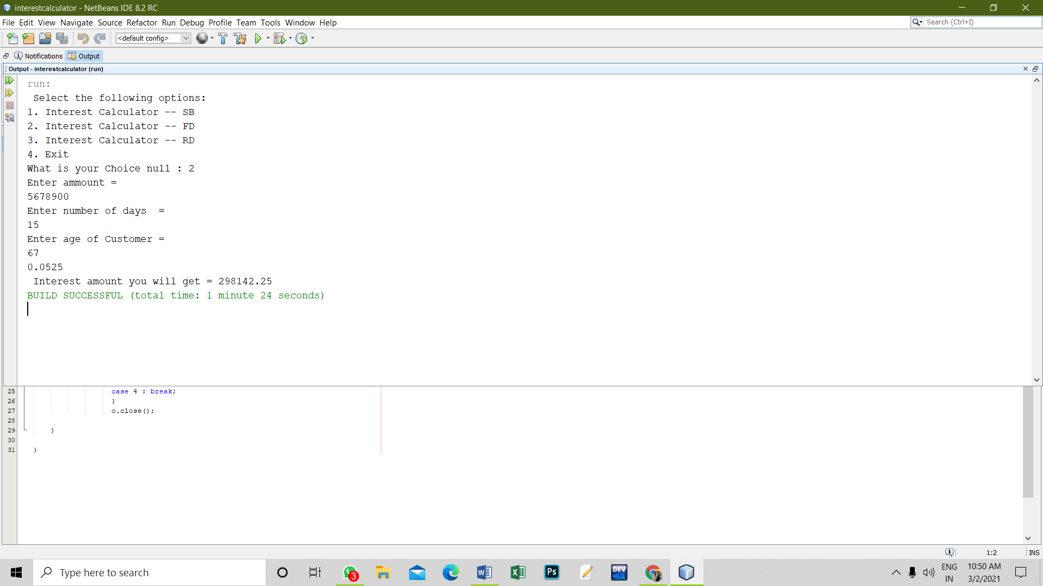

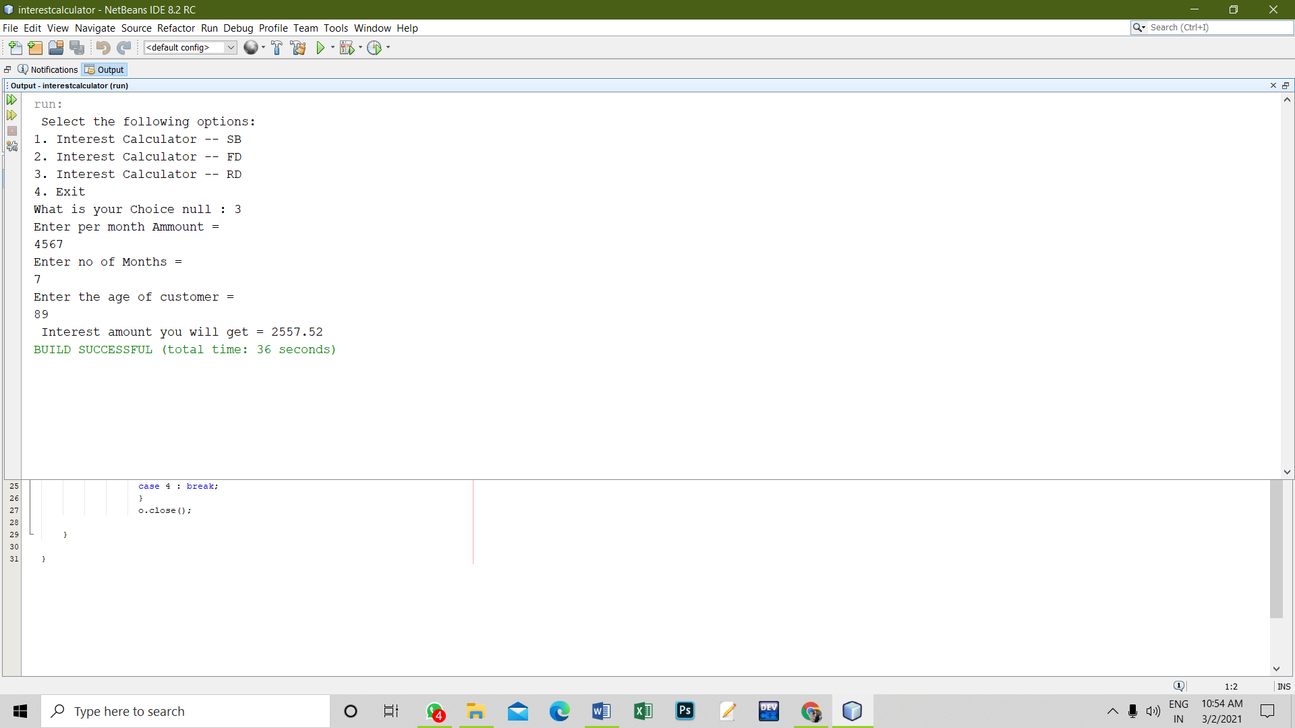

**11. Graphs (If Any): Image /Soft copy of graph paper to be attached here**

**no**

**Learning outcomes (What I have learnt):**

**1. I have learnt the concept of inheritance and types of inheritance.**

**2. I have learnt how to calculate the interest based on bank account age type of account.**

**3. I have learnt how to use extends keyword.**

**4. I have learnt how to correct errors.**

**5. I have learnt how to execute the application.**

**Evaluation Grid (To be created as per the SOP and Assessment guidelines by the faculty):**

|  |  |  |  |
| --- | --- | --- | --- |
| Sr. No. | Parameters | Marks Obtained | Maximum Marks |
| 1. |  |  |  |
| 2. |  |  |  |
| 3. |  |  |  |
|  |  |  |  |